Lab Report Template

Title: Project 1

Date:

Group Members: Braeden, Islam

Course: CS430

Instructor:Brad

**Introduction**

For this project we were assigned 5 problems involving cryptography. Cryptography is used to encrypt data so unintended people don’t have access to the data. To do this the intended user needs to be able to decrypt it so they can read the data.

**Objectives**

Objectives for this lab were to learn how to use cryptography and how to use ciphers.

**Methods**

For the programing portion of this lab, we used java to code a program that counts the number of each letters occurrence in a string, and then allows the user to replace each letter with a key. We used string manipulation to count the letters and then used java collections to replace each letter with the key. To solve the ciphers, we used the program or just worked them out on paper.

**Results**

Everything worked out perfectly, the code has no known bugs.

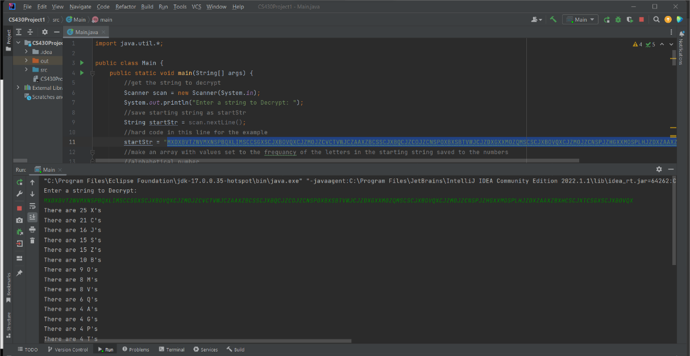

**Analysis**

No real patterns that weren’t expected, like that the most common letters will be E, T, A.

**Conclusion**

No real findings, questions were mostly independent and didn’t have a results asides from the key for the decrypted text.

**Appendix**

Code is attached, to run just upload and follow the prompt, right now I have the desired string hard coded so you don’t have to put in the exact string to get the string for this problem.